 | Mandatory disclosure updated on | 19-09-2018
1 | AICTE File no. | F.No.North-West/1-3512553456/2018/EOA
 | date and period of last approval | 10 April 2018 for A.Y 2018-19
2 | Name of the institution | Sat Priya Group of Institutions,Rohtak
 | Address of the institution | 0.5 K.M Milestone,Jind Road,Rohtak-124001
 | City & Pin code | Rohtak-124001
 | State/UT | Haryana
 | Phone number with STD code | +91-01262-290500
 | FAX number with STD code | +91-01262-290500
 | Email: | spiet2007@gmail.com
 | Website | www.Spgoi.com
 | nearest railway station(dis in KM) | Rohtak,3 K.M
 | Near bus stand | Rohtak
 | Nearest Airport(dist in km) | Indira Gandhi International Airport New Delhi, 70 KM
3 | Type of institution | Private-Self Financed/Unaided
 | Category(1)of the institution | Non Minority
 | Category (2) of the institution | Co-Education
4 | Name of the Organization running the Institute | Sat Priya Mehamia Memorial Educational Trust, Rohtak
 | Type of Organization | Educational Society
 | Address of Organization | 0.5 K.M Milestone,Jind Road,Rohtak-124001
 | Registered with | 3882
 | Registration date | 27-07-1998
 | Website of organization (society of | www.spmmet.com
 | trust website)
5 | NAME of the Affiliating university | Maharshi Dayanand University, Rohtak
 | Address | Delhi Road, University Secretariat,
 |  | Rohtak, Haryana 124001
 | Website of the university | www.mdurohtak.ac.in
 | Latest Affiliation Period | 2018-19
6 | Name of Director/Principal | Dr. Hitesh Kumar Dhal
 | Exact-Designation | Director
 | Phone No. with STD Code | +91-01262-290500,8222931604
 | Fax No. with STD Code | +91-01262-290500
 | E-Mail Id | hitesh_dhall001@yahoo.co.in
 | Highest Degree | Ph.D
 | Field of Specialization | Computer Science

7. Governing Board Members list:
S.No. | Name of the Directors/member | Designation
1 | Mr.Mukesh Arya | Chairman Trust
2 | Mr.Anil Kumar Arya | Trustee
3 | Mr. Sunil Kumar Arya | Trustee
4 | Mr. Rakesh Kuamr Arya | Trustee
5 | Mr. Seema Arya | Trustee
6 | Mr. Sahil Arya | Trustee
 | Frequency of Governing Body Meeting and  Date of last Meeting | Twice in a year,  21/08/2018
8. Academic Advisory Body-
Name | Designation
Mr. Mukesh Arya | Chairman
Dr. Hitesh Kumar Dhal | Director
Dr. Dolly | HOD & Professor
Dr. Sangeeta Malik | HOD &Associate Professor
Ms. Rupali | HOD &Assistant Professor
Mr. Rajender Kashyap | HOD &Assistant Professor
Mr. Pardeep | HOD &Assistant Professor
Ms.Taruna Sikka | HOD &Assistant Professor
Ms.Isha Sharma | Assistant Professor
Ms.Neha Dhankhar | Assistant Professor
Mr.Manish | Assistant Professor
Frequency of Governing Body Meeting and  Date of last Meeting | Twice in a year,  21/08/2018

9. Organization Chart-

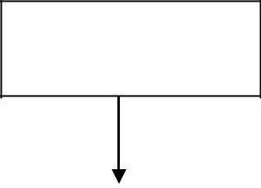
TRUSTEES

GOVERNING BODY |  | CHAIRMAN |  | COMMITTEE MEMBERS
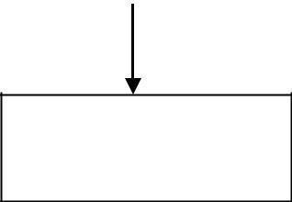

DIRECTOR

 |  | TEACHING STAFF
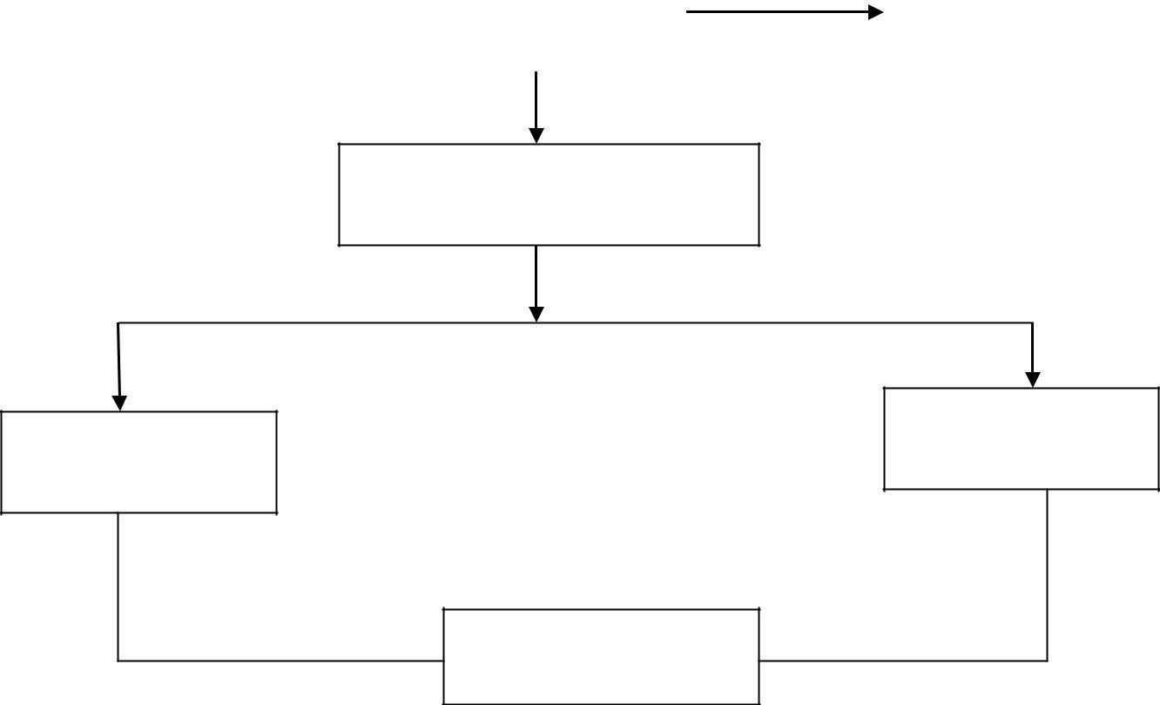  DIRECTOR |  | TEACHING STAFF

OFFICE SUPERINTENDENT

ACCOUNTANT
SENIOR CLERK

OFFICE ASSISTANT

Student feedback mechanism on  Institutional Governance/faculty  performance |  | Online Feedback System
10 | Name of the Department | Management
 | Course | MBA
 | Level | POST GRADUATE
 | 1st year approval by the council | 2007
 | Sanction Intake | 60
 | Admissions in 2018-19 | 10

11 | Name of the Department | Computer Science
 | Course | MCA
 | Level | POST GRADUATE
 | 1st year approval by the council | 2008
 | Sanction Intake | 60
 | Admissions in 2018-19 | 03

12 | Name of the Department | Computer Science and Engineering
 | Course | M.tech (computer science &  Engineering)
 | Level | POST GRADUATE
 | 1st year approval by the council | 2011
 | Sanction Intake | 18
 | Admissions in 2018-19 | 4

13 | Name of the Department | Mechanical Engineering
 | Course | M.TECH ( Mechanical Engineering )
 | Level | POST GRADUATE
 | 1st year approval by the council | 2013(Second Shift)
 | Sanction Intake | 24
 | Admissions in 2018-19 | 3

14 | Name of the Department | Civil Transportation Engineering
 | Course | M.TECH (Civil Transportation Engineering)
 | Level | POST GRADUATE
 | 1st year approval by the council | 2014
 | Sanction Intake | 24
 | Admissions in 2018-19 | 21

15 | Name of the Department | Electronic & Communication Engineering
 | Course | M.TECH ( Electronic & Communication Engineering )
 | Level | POST GRADUATE
 | 1st year approval by the council | 2013
 | Sanction Intake | 24(Second Shift)
 | Admissions in 2018-19 | 5
16 | Name of the Department | Computer Science and Engineering
 | Course | B.TECH (Computer Science & Engineering)
 | Level | Under Graduate
 | 1st year approval by the council | 2007
 | Sanction Intake | 60
 | Admissions in 2018-19 | 1
17 | Name of the Department | Mechanical Engineering
 | Course | B.TECH ( Mechanical Engineering )
 | Level | Under Graduate
 | 1st year approval by the council | 2007
 | Sanction Intake | 60
 | Admissions in 2018-19 | 1
18 | Name of the Department | Civil Engineering
 | Course | B.TECH (Civil Engineering)
 | Level | Under Graduate
 | 1st year approval by the council | 2010
 | Sanction Intake | 60
 | Admissions in 2018-19 | 1
19 | Name of the Department | Electronic & Communication Engineering
 | Course | B.TECH ( Electronic & Communication Engineering )
 | Level | Under Graduate
 | 1st year approval by the council | 2007
 | Sanction Intake | 60
 | Admissions in 2018-19 | 1
20. Infrastructure Information :
Classrooms / Tutorial Room Facilities:-
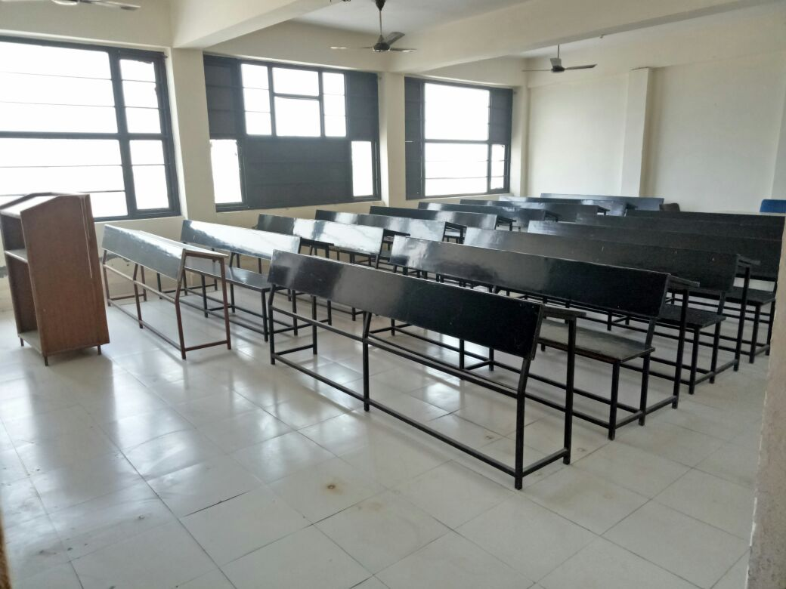
20(A) Computer Centre Facility:-
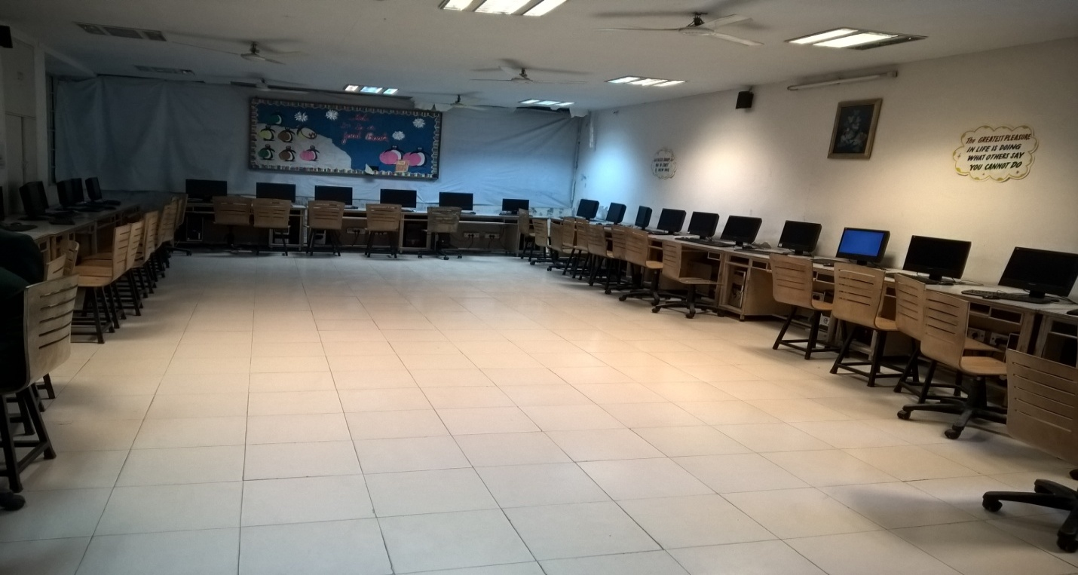
20(B) Library Facilities:-
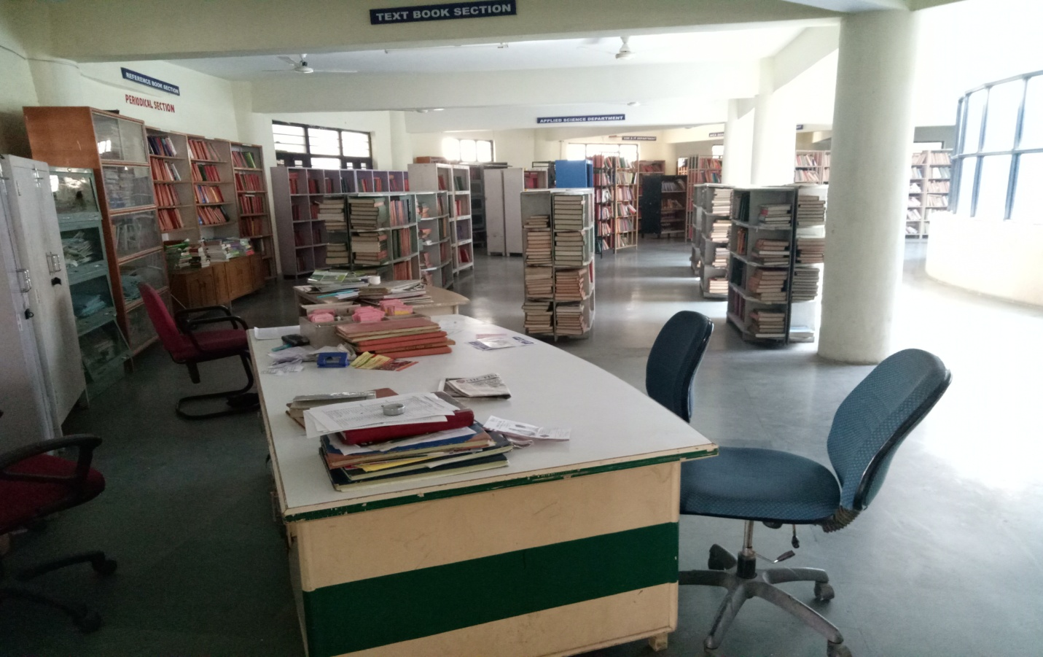
20 (c)Indoor Sports Facilities :-
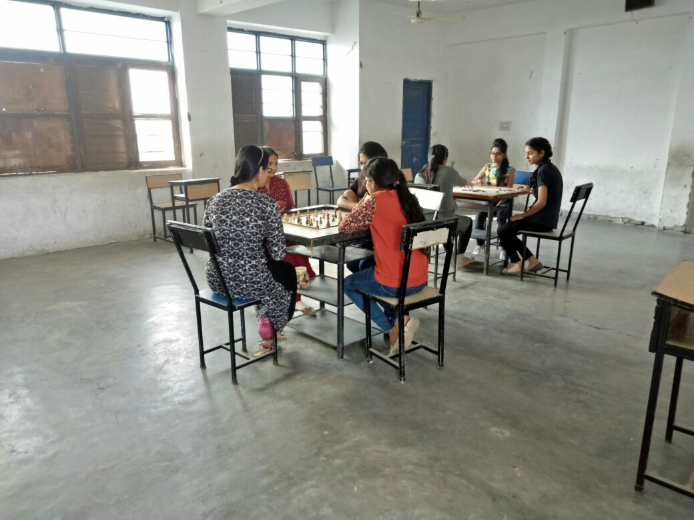
20(D) Ground Sports Facilities:-
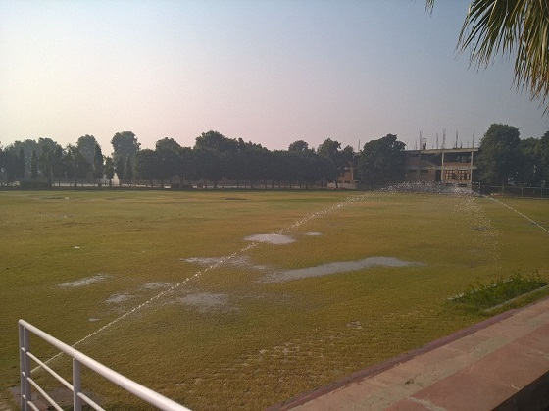

21 | Hostel | -
22 | Academic Sessions | As per AICTE, DTE
23 | Counseling / Mentoring | Yes
 | Career Counseling | Yes
 | Medical facilities | Yes
24 | Students Activity Body | Yes
 | Cultural Activities | Yes
 | Sports Activities | Yes
 | Literary Activities | Yes
 | Magazine / Newsletter | Yes
 | Technical activities / TechFest | Yes
 | Industrial Visits / Tours | Yes
 | Alumni activities | Yes

25. FACULTY DETAILS
Sr. NO. | Sr. NO. | Title | First Name | Last Name | Exact Designation | Department
1 | 1 | Mr. | ANKUR | NARWAL | LECTURER | CIVIL ENGINEERING
2 | 2 | Mr. | HARINDER | SHEORAN | ASST PROFESSOR | CIVIL ENGINEERING
3 | 3 | Mr. | SONU | GOYAT | LECTURER | CIVIL ENGINEERING
4 | 4 | Mr. | PARDEEP | SINGH | LECTURER | CIVIL ENGINEERING
5 | 5 | Mr. | NAVEEN | SHARMA | LECTURER | CIVIL ENGINEERING
6 | 6 | Mr. | AMIT | SHEORAN | LECTURER | CIVIL ENGINEERING
7 | 7 | Mr. | RAKESH | KUMAR | LECTURER | CIVIL ENGINEERING
8 | 8 | Mr. | AMIT | KAUSHIK | LECTURER | CIVIL ENGINEERING
9 | 9 | Mr. | GOVIND | SINGH | LECTURER | CIVIL ENGINEERING
10 | 10 | Mr. | ARUN | SAINI | LECTURER | CIVIL ENGINEERING
11 | 11 | Mr. | ANUJ | NARWAL | ASST PROFESSOR | CIVIL ENGINEERING
12 | 12 | Ms. | MONIKA | MONIKA | ASST PROFESSOR | CIVIL ENGINEERING
13 | 1 | Dr. | MUKESH | SINGLA | PROFESSOR | COMPUTER SCEINCE & ENGINEERING
14 | 2 | Ms. | RAJSHREE | VASHIST | ASST PROFESSOR | COMPUTER SCEINCE & ENGINEERING
15 | 3 | Miss | HIMANSHI | VERMA | LECTURER | COMPUTER SCEINCE & ENGINEERING
16 | 4 | Mrs. | SUSHMA | RANI | ASST PROFESSOR | COMPUTER SCEINCE & ENGINEERING
17 | 5 | Mrs. | KOMAL | ARORA | ASST PROFESSOR | COMPUTER SCEINCE & ENGINEERING
18 | 6 | Miss | NEELAM | GOSWAMI | ASST PROFESSOR | COMPUTER SCEINCE & ENGINEERING
19 | 7 | Ms. | KANIKA | MIGLANI | ASST PROFESSOR | COMPUTER SCIENCE & ENGINEERING
20 | 8 | Mr. | SANDEEP | SHARMA | ASST PROFESSOR | COMPUTER SCIENCE & ENGINEERING
21 | 9 | Mr. | BRAHAMJIT | PANNU | ASST PROFESSOR | COMPUTER SCIENCE & ENGINEERING
22 | 10 | Mr. | JATIN | MALIK | ASST PROFESSOR | COMPUTER SCIENCE & ENGINEERING
23 | 11 | Miss | RUPALI | AHUJA | HEAD OF DEPT | COMPUTER SCIENCE & ENGINEERING
24 | 12 | Ms. | HEMANI | MALHOTRA | ASST PROFESSOR | COMPUTER SCIENCE & ENGINEERING
25 | 1 | Ms. | MONIKA | SEHRAWAT | ASST PROFESSOR | ELECTRONICS & COMMUNICATION ENGG
26 | 2 | Ms. | NEETU | DALAL | ASST PROFESSOR | ELECTRONICS & COMMUNICATION ENGG
27 | 3 | Ms. | NEHA | SHARMA | ASST PROFESSOR | ELECTRONICS & COMMUNICATION ENGG
28 | 4 | Mr. | PRIKSHIT | SHARMA | ASST PROFESSOR | ELECTRONICS & COMMUNICATION ENGG
29 | 5 | Ms. | TARUNA | KINRA | ASST PROFESSOR | ELECTRONICS & COMMUNICATION ENGG
30 | 6 | Ms. | JYOTI | JOSHI | LECTURER | ELECTRONICS & COMMUNICATION ENGG
31 | 7 | Mr. | RAHUL | SHARMA | LECTURER | ELECTRONICS & COMMUNICATION ENGG
32 | 8 | Ms. | ISHA | SHARMA | ASST PROFESSOR | ELECTRONICS & COMMUNICATION ENGG
33 | 9 | Ms. | PREETI | RATHEE | LECTURER | ELECTRONICS & COMMUNICATION ENGG
34 | 10 | Mr. | DEEPAK | BUDHWAR | ASST PROFESSOR | ELECTRONICS & COMMUNICATION ENGG
35 | 11 | Miss | TARUNA | SIKKA | ASST PROFESSOR | ELECTRONICS & COMMUNICATION ENGG
36 | 12 | Miss | NISHA | GHANGHASH | ASST PROFESSOR | ELECTRONICS & COMMUNICATION ENGG
37 | 13 | Miss | PRIYANKA | SHARMA | ASST PROFESSOR | ELECTRONICS & COMMUNICATION ENGG
38 | 14 | Miss | ANKITA | SHARMA | ASST PROFESSOR | ELECTRONICS & COMMUNICATION ENGG
39 | 15 | Ms. | BHAWNA |  | ASST PROFESSOR | ELECTRONICS & COMMUNICATION ENGG
40 | 16 | Ms. | KIRTI |  | ASST PROFESSOR | ELECTRONICS & COMMUNICATION ENGG
41 | 1 | Ms. | PUNAM | RANI | ASST PROFESSOR | FIRST YEAR/OTHER
42 | 2 | Ms. | ANNU | ANNU | ASST PROFESSOR | FIRST YEAR/OTHER
43 | 3 | Mr. | JUBIN | BHUTANI | ASST PROFESSOR | FIRST YEAR/OTHER
44 | 4 | Mr. | NAVEEN | NARWAL | ASST PROFESSOR | FIRST YEAR/OTHER
45 | 5 | Ms. | SARITA | SARITA | ASST PROFESSOR | FIRST YEAR/OTHER
46 | 6 | Mr. | MOHD. | SIDDIQUIE | ASST PROFESSOR | FIRST YEAR/OTHER
47 | 7 | Ms. | NEHARIKA | NEHARIKA | ASST PROFESSOR | FIRST YEAR/OTHER
48 | 8 | Ms. | NISHA | VIRMANI | ASST PROFESSOR | FIRST YEAR/OTHER
49 | 9 | Mr. | DEVENDER | SAINI | ASST PROFESSOR | FIRST YEAR/OTHER
50 | 10 | Ms. | SONIA | SONIA | LECTURER | FIRST YEAR/OTHER
51 | 11 | Dr. | SANGEETA | RANI | ASSOCIATE PROFESSOR | FIRST YEAR/OTHER
52 | 12 | Ms. | MAMTA | CHHABRA | ASST PROFESSOR | FIRST YEAR/OTHER
53 | 1 | Ms. | JYOTI | KAPOOR | ASST PROFESSOR | MASTER OF COMPUTER APPLICATIONS
54 | 2 | Mrs. | BABITA | SINGH | ASST PROFESSOR | MASTER OF COMPUTER APPLICATIONS
55 | 3 | Ms. | REENA | KUMARI | ASST PROFESSOR | MASTER OF COMPUTER APPLICATIONS
56 | 4 | Ms. | MONIKA | SAINI | ASST PROFESSOR | MASTER OF COMPUTER APPLICATIONS
57 | 5 | Ms. | ANJALI | BAJAJ | ASST PROFESSOR | MASTER OF COMPUTER APPLICATIONS
58 | 6 | Mr. | PARVEEN | BANSAL | ASST PROFESSOR | MASTER OF COMPUTER APPLICATIONS
59 | 7 | Dr. | HITESH | DHAL | DIRECTOR | MASTER OF COMPUTER APPLICATIONS
60 | 8 | Dr. | DOLLY | DHALL | PROFESSOR | MASTER OF COMPUTER APPLICATIONS
61 | 9 | Ms. | PARUL |  | ASST PROFESSOR | MASTER OF COMPUTER APPLICATIONS
62 | 1 | Ms. | NEHA | DHANKHAR | ASST PROFESSOR | MASTERS IN BUSINESS ADMINISTRATION
63 | 2 | Ms. | SHRUTI | BALHARA | ASST PROFESSOR | MASTERS IN BUSINESS ADMINISTRATION
64 | 3 | Ms. | NEENA | TEHLAN | ASST PROFESSOR | MASTERS IN BUSINESS ADMINISTRATION
65 | 4 | Ms. | SNEHA | SAHNI | ASST PROFESSOR | MASTERS IN BUSINESS ADMINISTRATION
66 | 5 | Ms. | ISHU | DHANKHAR | ASST PROFESSOR | MASTERS IN BUSINESS ADMINISTRATION
67 | 6 | Ms. | RICHA | DAHIYA | ASST PROFESSOR | MASTERS IN BUSINESS ADMINISTRATION
68 | 1 | Mr. | RAJENDER | KASHYAP | ASST PROFESSOR | MECHANICAL ENGINEERING
69 | 2 | Mr. | RAVI | CHAHAL | ASST PROFESSOR | MECHANICAL ENGINEERING
70 | 3 | Mr. | BHUPENDER | SINGH | ASST PROFESSOR | MECHANICAL ENGINEERING
71 | 4 | Mr. | SURENDER | KUMAR | LECTURER | MECHANICAL ENGINEERING
72 | 5 | Mr. | AMIT | KUMAR | LECTURER | MECHANICAL ENGINEERING
73 | 6 | Mr. | MANISH | KUMAR | ASST PROFESSOR | MECHANICAL ENGINEERING
74 | 7 | Mr. | SUSHIL | KAMAT | ASST PROFESSOR | MECHANICAL ENGINEERING
75 | 8 | Mr. | KULDEEP | MALIK | ASST PROFESSOR | MECHANICAL ENGINEERING
76 | 9 | Ms. | KESHAR | BAI | ASST PROFESSOR | MECHANICAL ENGINEERING
77 | 10 | Mr. | SUNNY | DANGI | LECTURER | MECHANICAL ENGINEERING
78 | 11 | Mr. | DEEPAK | DAHIYA | ASST PROFESSOR | MECHANICAL ENGINEERING
79 | 12 | Mr. | AMIT | AHLAWAT | LECTURER | MECHANICAL ENGINEERING

26. PLACEMENT DETAILS OF LAST THREE YEARS
 | PLACEMENT DETAIL OF 2017-18
SR.No. | Programme | Name of the Course | Approved Intake | Number Of Eligible Students | Number Of Students Placed in IT | Number Of Students Placed in Non IT | Total Student Placed (IT+ Non IT) | Number Of Companies Visited | Lowest Package(In Lakhs) | Highest Package(In Lakhs)
1 | ENGINEERING AND TECHNOLOGY | CIVIL ENGINEERING | 24 | 6 | 0 | 4 | 4 | 0 | 2 | 2
2 | MCA | MASTERS IN COMPUTER APPLICATIONS | 60 | 3 | 1 | 1 | 2 | 0 | 2 | 3
3 | ENGINEERING AND TECHNOLOGY | M.TECH CIVIL ENGINEERING | 60 | 10 | 0 | 2 | 2 | 0 | 2 | 2
4 | ENGINEERING AND TECHNOLOGY | MECHANICAL ENGINEERING | 60 | 11 | 0 | 6 | 6 | 0 | 2 | 2
5 | ENGINEERING AND TECHNOLOGY | M.TECH COMPUTER SCIENCE AND ENGINEERING | 18 | 4 | 1 | 1 | 2 | 0 | 2 | 4
6 | ENGINEERING AND TECHNOLOGY | ELECTRONICS AND COMMUNICATIONS ENGINEERING | 60 | 4 | 0 | 2 | 2 | 0 | 2 | 2
7 | ENGINEERING AND TECHNOLOGY | COMPUTER SCIENCE AND ENGINEERING | 60 | 0 | 0 | 0 | 0 | 0 | 0 | 0
8 | MANAGEMENT | MASTERS IN BUSINESS ADMINISTRATION | 60 | 0 | 0 | 0 | 0 | 0 | 0 | 0
9 | ENGINEERING AND TECHNOLOGY | M.TECH ELECTRONICS AND COMMUNICATIONS ENGINEERING | 24 | 3 | 0 | 3 | 3 | 0 | 2 | 2
10 | ENGINEERING AND TECHNOLOGY | M.TECH MECHANICAL ENGINEERING | 24 | 3 | 0 | 2 | 2 | 0 | 2 | 2
 | PLACEMENT DETAIL OF 2016-17
SR.No. | Programme | Name of the Course | Approved Intake | Number Of Eligible Students | Number Of Students Placed in IT | Number Of Students Placed in Non IT | Total Student Placed (IT+ Non IT) | Number Of Companies Visited | Lowest Package(In Lakhs) | Highest Package(In Lakhs)
1 | ENGINEERING AND TECHNOLOGY | CIVIL ENGINEERING | 24 | 4 | 0 | 2 | 2 | 1 | 1 | 3
2 | MCA | MASTERS IN COMPUTER APPLICATIONS | 60 | 25 | 10 | 5 | 15 | 2 | 1 | 2
3 | ENGINEERING AND TECHNOLOGY | M.TECH CIVIL ENGINEERING | 60 | 20 | 5 | 9 | 14 | 1 | 1 | 2
4 | ENGINEERING AND TECHNOLOGY | MECHANICAL ENGINEERING | 60 | 25 | 4 | 8 | 12 | 2 | 2 | 2
5 | ENGINEERING AND TECHNOLOGY | M.TECH COMPUTER SCIENCE AND ENGINEERING | 18 | 18 | 15 | 1 | 16 | 2 | 2 | 3
6 | ENGINEERING AND TECHNOLOGY | ELECTRONICS AND COMMUNICATIONS ENGINEERING | 60 | 5 | 2 | 1 | 3 | 1 | 1 | 2
7 | ENGINEERING AND TECHNOLOGY | COMPUTER SCIENCE AND ENGINEERING | 60 | 4 | 2 | 0 | 2 | 2 | 1 | 2
8 | MANAGEMENT | MASTERS IN BUSINESS ADMINISTRATION | 60 | 0 | 0 | 0 | 0 | 0 | 0 | 0
9 | ENGINEERING AND TECHNOLOGY | M.TECH ELECTRONICS AND COMMUNICATIONS ENGINEERING | 24 | 10 | 2 | 1 | 3 | 1 | 1 | 3
10 | ENGINEERING AND TECHNOLOGY | M.TECH MECHANICAL ENGINEERING | 24 | 6 | 1 | 1 | 2 | 1 | 1 | 2
 | PLACEMENT DETAIL OF 2015-16
SR.No. | Programme | Name of the Course | Approved Intake | Number Of Eligible Students | Number Of Students Placed in IT | Number Of Students Placed in Non IT | Total Student Placed (IT+ Non IT) | Number Of Companies Visited | Lowest Package(In Lakhs) | Highest Package(In Lakhs)
1 | ENGINEERING AND TECHNOLOGY | CIVIL ENGINEERING | 24 | 0 | 0 | 0 | 0 | 0 | 0 | 0
2 | MCA | MASTERS IN COMPUTER APPLICATIONS | 60 | 15 | 4 | 2 | 6 | 3 | 2 | 3
3 | ENGINEERING AND TECHNOLOGY | M.TECH CIVIL ENGINEERING | 60 | 30 | 15 | 5 | 20 | 3 | 2 | 3
4 | ENGINEERING AND TECHNOLOGY | MECHANICAL ENGINEERING | 60 | 12 | 6 | 2 | 8 | 3 | 1 | 4
5 | ENGINEERING AND TECHNOLOGY | M.TECH COMPUTER SCIENCE AND ENGINEERING | 18 | 15 | 5 | 3 | 8 | 3 | 2 | 3
6 | ENGINEERING AND TECHNOLOGY | ELECTRONICS AND COMMUNICATIONS ENGINEERING | 120 | 20 | 6 | 2 | 8 | 2 | 1 | 3
7 | ENGINEERING AND TECHNOLOGY | COMPUTER SCIENCE AND ENGINEERING | 60 | 18 | 8 | 4 | 12 | 3 | 1 | 4
8 | MANAGEMENT | MASTERS IN BUSINESS ADMINISTRATION | 60 | 0 | 0 | 0 | 0 | 0 | 0 | 0
9 | ENGINEERING AND TECHNOLOGY | M.TECH ELECTRONICS AND COMMUNICATIONS ENGINEERING | 24 | 11 | 2 | 1 | 3 | 2 | 2 | 4
10 | ENGINEERING AND TECHNOLOGY | M.TECH MECHANICAL ENGINEERING | 24 | 2 | 1 | 0 | 1 | 2 | 2 | 2

27. ADMISSION STATUS OF LAST 4 YEARS

Course-wise | Academic Year 2015-16 | Academic Year 2016-17 | Academic Year 2017-18 | Academic Year 2018-19
B.Tech | 149 | 72 | 30 | 16
M.Tech | 63 | 16 | 21 | 49
MCA | 39 | 13 | 3 | 05
MBA | 18 | 0 | 13 | 20
BBA | 0 | 0 | 0 | 08
BCA | 0 | 0 | 14 | 09
Total | 269 | 101 | 81 | 107

